Word Clouds Example Solution
Looking at the word clouds of positive responses (Figure 1) and negative responses (Figure 2), some patterns start to emerge.
On the positive side, students valued the professor who taught the course, and feel they have gained useful practical skills which have broadened their skillset, and felt supported on the course. Some students found the course a bit easy, and others appreciated the practical and data-driven nature of the course.
Figure 1: Word cloud showing commonly used words in students’ responses asking what was positive about the course.
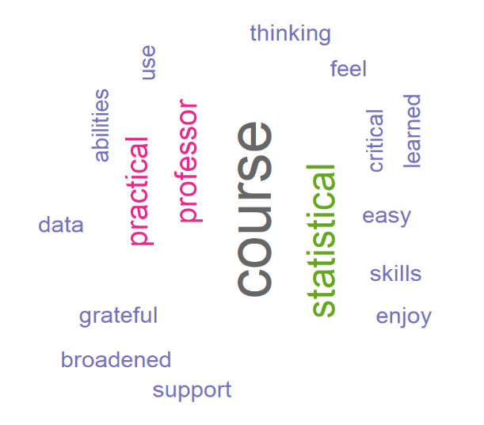

However, on the negative side, students have struggled with managing the workload and assignments, and some had issues with the difficulty of material. Multiple students mentioned time as an issue for them, with others explicitly stating that balancing their workload was a struggle, which was probably compounded by other commitments to a job or family.

Figure 2: Word cloud showing commonly used words in students’ responses asking what was negative about the course.
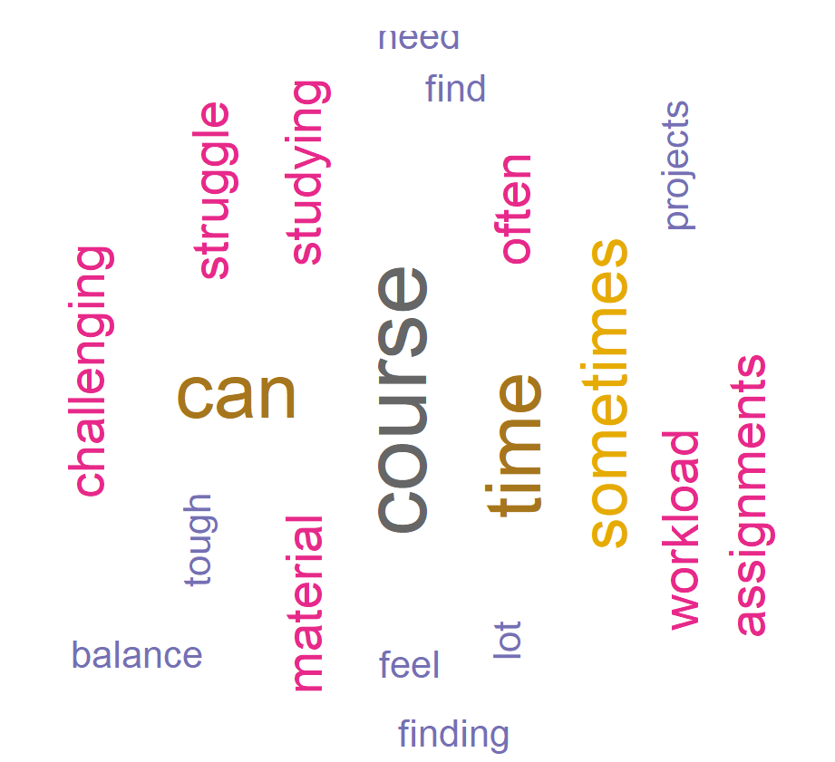

Sample R Code
library("tm")
library("SnowballC")
library("wordcloud")
library("RColorBrewer")

# Positive Comments

commentsa=readLines("Positive comments.txt")
text=Corpus(VectorSource(commentsa))

# Convert the text to lower case
text=tm_map(text, content_transformer(tolower))
# Remove English common stopwords
text = tm_map(text, removeWords, stopwords("english"))
text=tm_map(text, removeWords, "statistics")

dtm = TermDocumentMatrix(text)
m = as.matrix(dtm)
v = sort(rowSums(m),decreasing=TRUE)
d = data.frame(word = names(v),freq=v)
head(d, 10)
par(mar = c(2, 2, 2, 2)) # Set the margin on all sides to 2

set.seed(1234)
wordcloud(words = d$word, freq = d$freq, min.freq = 2,
max.words=200, random.order=FALSE, rot.per=0.35,
colors=brewer.pal(8, "Dark2"))

# Negative Comments

commentsb=readLines("Negative comments.txt")
text=Corpus(VectorSource(commentsb))

# Convert the text to lower case
text=tm_map(text, content_transformer(tolower))
# Remove English common stopwords
text = tm_map(text, removeWords, stopwords("english"))
text=tm_map(text, removeWords, "statistics")

dtm = TermDocumentMatrix(text)
m = as.matrix(dtm)
v = sort(rowSums(m),decreasing=TRUE)
d = data.frame(word = names(v),freq=v)
head(d, 10)

set.seed(1234)
wordcloud(words = d$word, freq = d$freq, min.freq = 2,
max.words=200, random.order=FALSE, rot.per=0.35,
colors=brewer.pal(8, "Dark2"))

